Using Pivot Tables

**Introduction to Creating Pivot Tables in Excel**

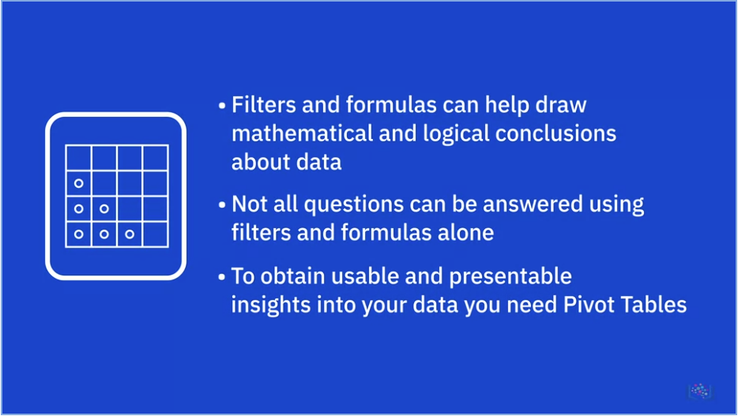

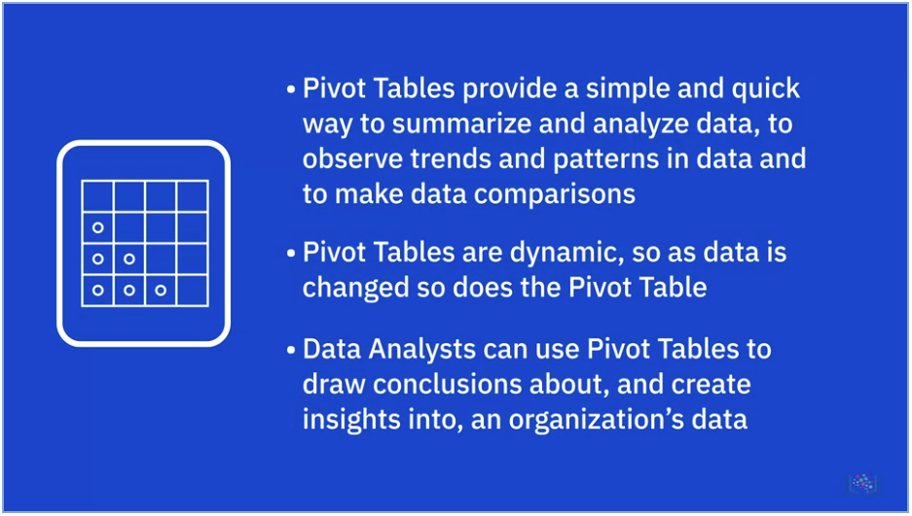

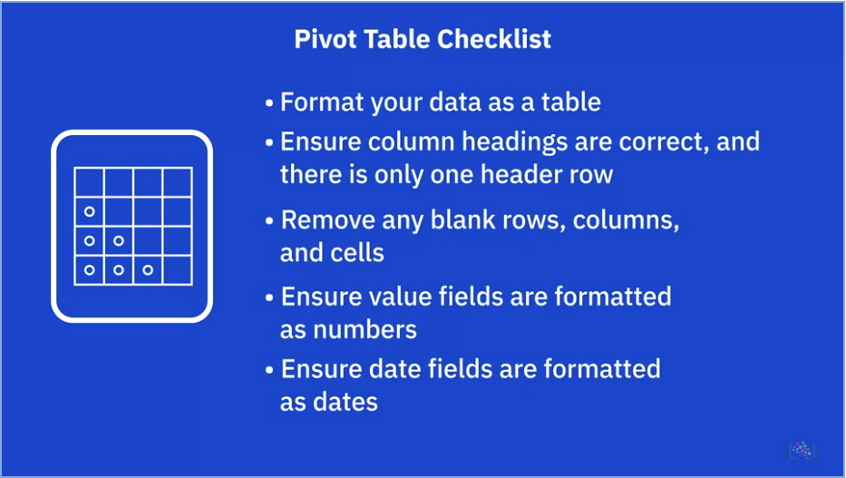

* To format the dataset as a table: Home tab > Styles group > Format as Table, and then filter drop-downs at top of columns will be added.
* To create a PivotTable, Insert tab > Tables group > PivotTable

**Pivot Table Features**

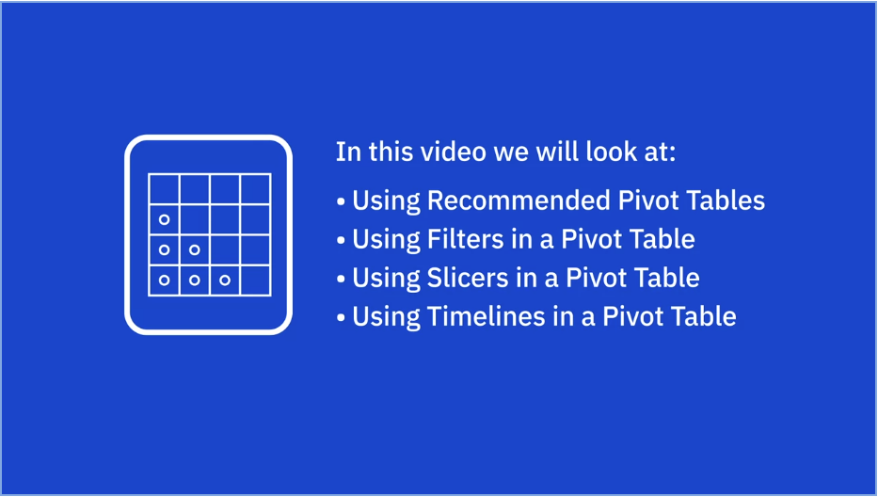

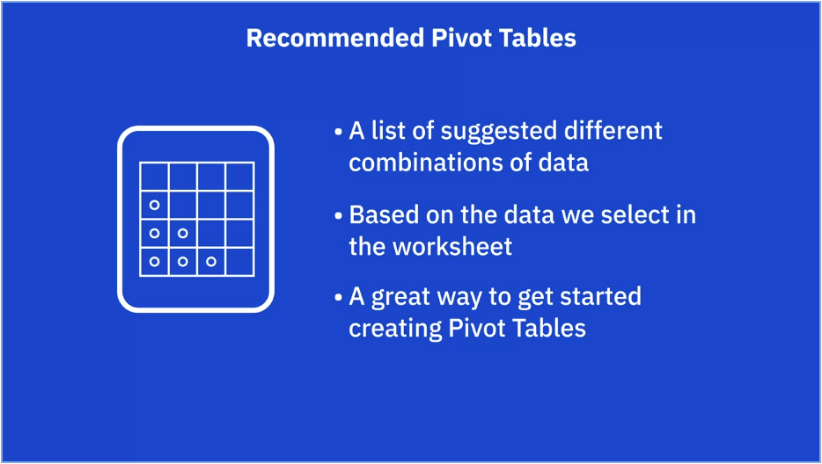

*Important: **Must select a cell** in the PivotTable **first before adding another slicer**

**Summary and Highlights**

In this lesson, you have learned the following information:

Pivot Tables:

* To obtain usable and presentable insights into your data you need to use Pivot Tables.
* Pivot tables provide a simple and quick way to summarize and analyze data, to observe trends and patterns in your data and to make comparisons of your data.
* Pivot tables are dynamic, so as you change and add data to the original dataset on which the pivot table is based, the analysis and summary information changes too.
* A Data Analyst can use pivot tables to draw useful and relevant conclusions about, and create insights into, an organization’s data in order to present those insights to interested parties within the company.

Use this Pivot Table checklist to ensure your data is in a fit state to make a Pivot Table:

* Format your data as a table for best results.
* Ensure column headings are correct, and there is only one header row, as these column headings become the field names in a Pivot Table.
* Remove any blank rows and columns, and try to eliminate blank cells also.
* Ensure value fields are formatted as numbers, and not text, and ensure date fields are formatted as dates, and not text.

Arranging Pivot Tables with Filters and Recommended Tables:

* You use the Pivot Table Fields pane to add and arrange data fields in your pivot table.
* Recommended Pivot Tables are a list of suggested different combinations of data that could be used when creating a Pivot Table, based on the data selected in the worksheet.

Filters and Slicers:

* Slicers are on-screen graphical filter objects that enable you to filter your data using buttons, which makes it easier to perform quick filtering of your pivot table data.
* Timelines are another type of filter tool that enable you to filter specifically on date-related data in your pivot table. This is a much quicker and more effective way of dynamically filtering by date, rather than having to create and adjust filters on your date columns.